[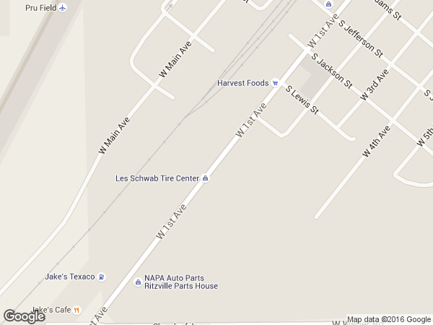](http://maps.google.com/?q=1102%20w%201st%20Ave,%20Ritzville%20WA%2099169)

Ag Tech Services